**P1 Category**

**Total Dies** # 10-3

**Pixel Rearrangement** # 50px

***Die # 10-3***

**Image 1:**

**Bottom-Left** # 338px, 547px

Same approach is used for all below DMs

|  |  |  |
| --- | --- | --- |
| Bottom-Left | 388px | 497px |
|  | -50px | +50px |
|  | **338px** | **547px** |

**Top-Right** # 662px, 323px

|  |  |  |
| --- | --- | --- |
| Top-Right | 612px | 273px |
|  | +50px | -50px |
|  | **662px** | **223** |

**Image 2:**

**Bottom-Left** # 609 px, 573px

**Top-Right** # 985px, 196px

**Image 3:**

**Bottom-Left** # 338px, 844px

**Top-Right** # 661px, 519px

**Image 4:**

**Bottom-Left** # 610px, 868px

**Top-Right** # 986px, 495px

**Image 5:**

**Bottom-Left** # 330px, 1148px

**Top-Right** # 670px, 807px

**Image 6:**

**Bottom-Left** # 599px, 1177px

**Top-Right** # 996px, 779px

**Image 7:**

**Bottom-Left** # 353px, 1693px

**Top-Right** # 641px, 1439px

**Image 8:**

**Bottom-Left** # 610px, 1693px

**Top-Right** # 973px,

px

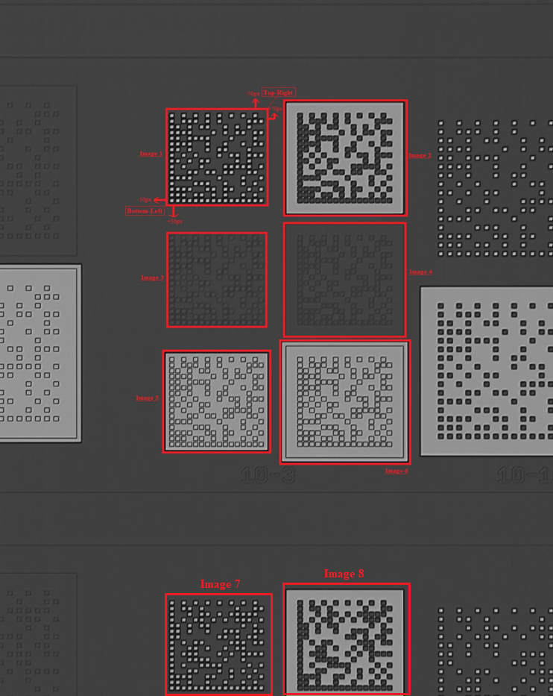

**P2 Category**

**Total Dies** # 5-0/10-0

**Pixel Rearrangement** # 50px

***Die # 5-0***

**Image 1:**

**Bottom-Left** # 102px, 928px

**Top-Right** # 310px, 719px

**Image 2:**

**Bottom-Left** # 239px, 918px

**Top-Right** # 428px, 727px

**Image 3:**

**Bottom-Left** # 100px, 1057px

**Top-Right** # 312px, 846px

**Image 4:**

**Bottom-Left** # 238px, 1047px

**Top-Right** # 428px, 857px

**Image 5:**

**Bottom-Left** # 91px, 1193px

**Top-Right** # 321px, 962px

**Image 6:**

**Bottom-Left** # 229px, 1184px

**Top-Right** # 439px, 974px

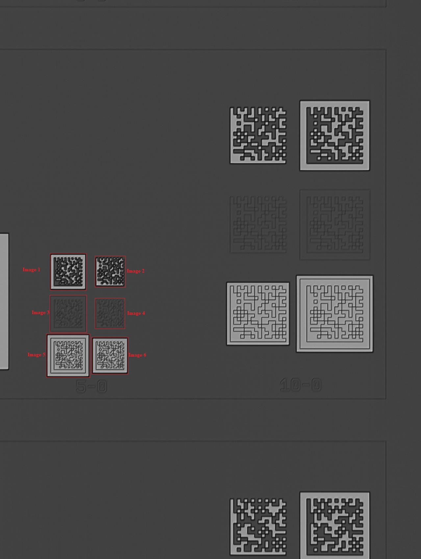**Top-Right** # 439px, 974px

***Die # 10-0***

**Image 1:**

**Bottom-Left** # 648px, 547px

**Top-Right** # 922px, 273px

**Image 2:**

**Bottom-Left** # 859px, 568px

**Top-Right** # 1175px, 253px

**Image 3:**

**Bottom-Left** # 646px, 819px

**Top-Right** # 921px, 545px

**Image 4:**

**Bottom-Left** # 859px, 839px

**Top-Right** # 1178px, 522px

**Image 5:**

**Bottom-Left** # 636px, 1099px

**Top-Right** # 931px, 803px

**Image 6:**

**Bottom-Left** # 849px, 1120px

**Top-Right** # 1186px, 783px

**Image 7:**

**Bottom-Left** # 653px, 1693px

**Top-Right** # 895px, 1482px

**Image 8:**

**Bottom-Left** # 872px, 1693px

**Top-Right** # 1171px, 1464px

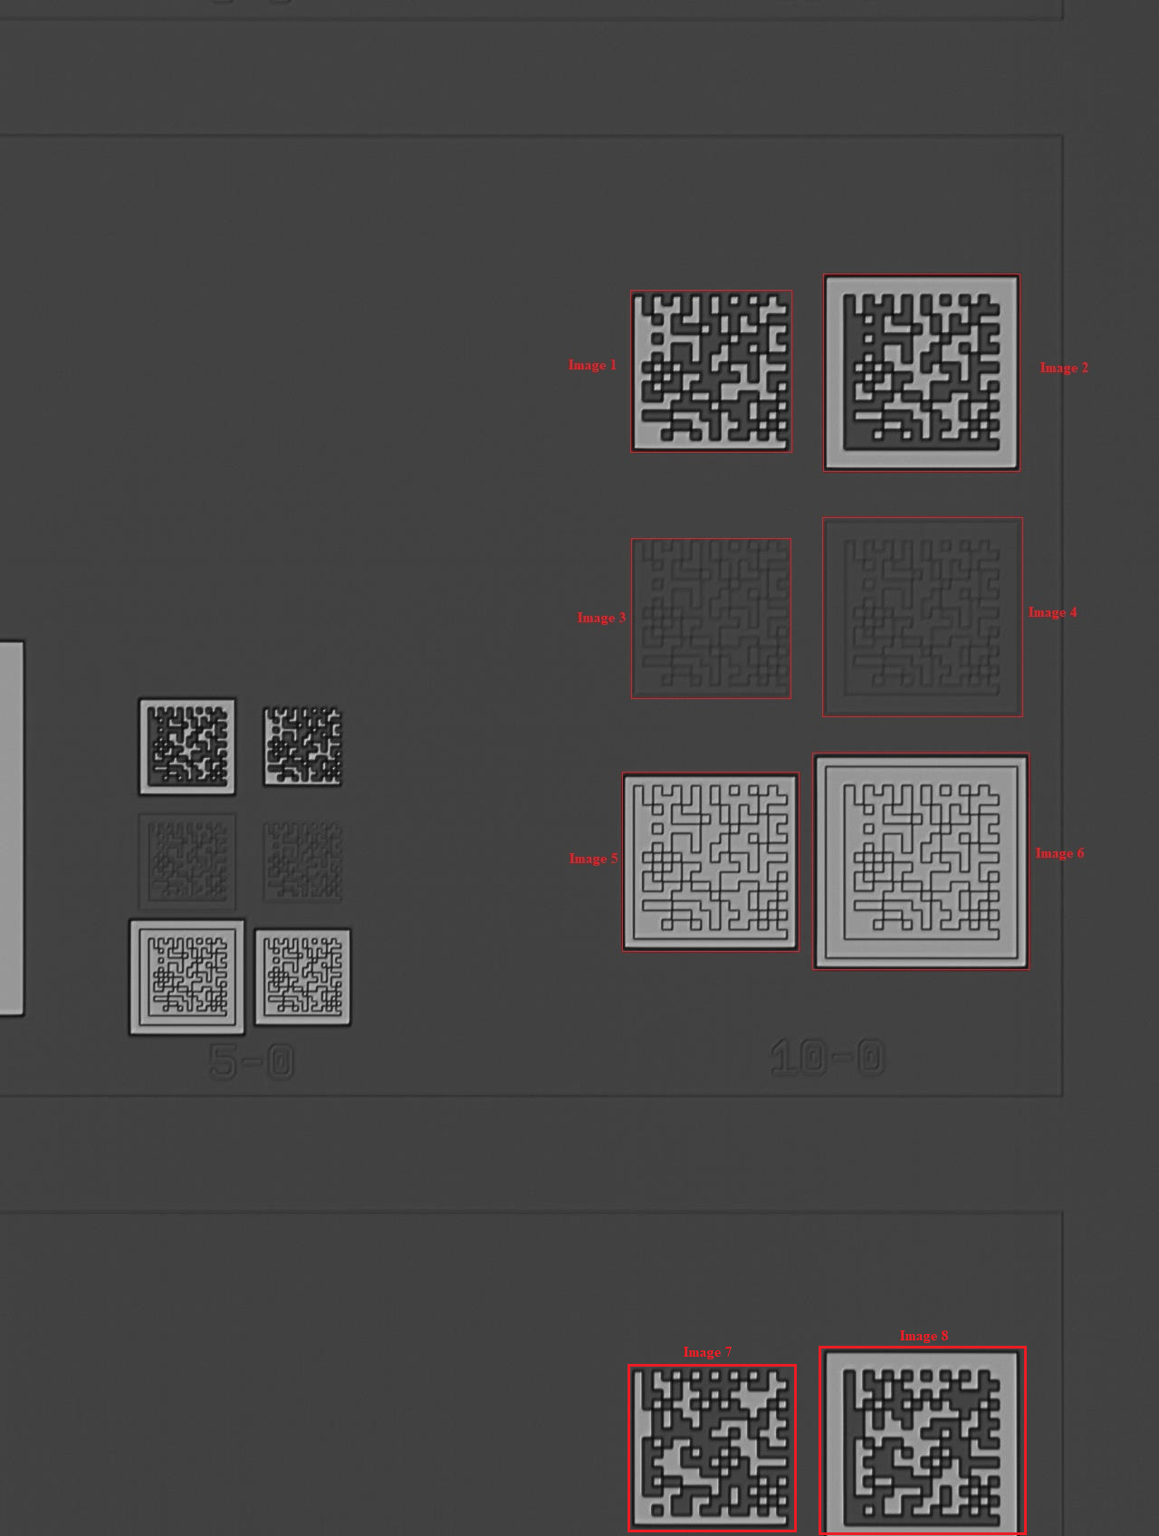

**P3 Category**

**Total Dies** # 5-5/3-1.5/3-1/2-2/3-3/3-0

**Pixel Rearrangement** # 50px

***Die # 5-5***

**Image 1:**

**Bottom-Left** # 92px, 999px

**Top-Right** # 362px, 728px

**Image 2:**

**Bottom-Left** # 315px, 1021px

**Top-Right** # 625px, 707px

**Image 3:**

**Bottom-Left** # 579px, 1000px

**Top-Right** # 851px, 726px

**Image 4:**

**Bottom-Left** # 81px, 1241px

**Top-Right** # 372px, 950px

**Image 5:**

**Bottom-Left** # 305px, 1261px

**Top-Right** # 635px, 929px

**Image 6:**

**Bottom-Left** # 559px, 1251px

**Top-Right** # 870px, 940px

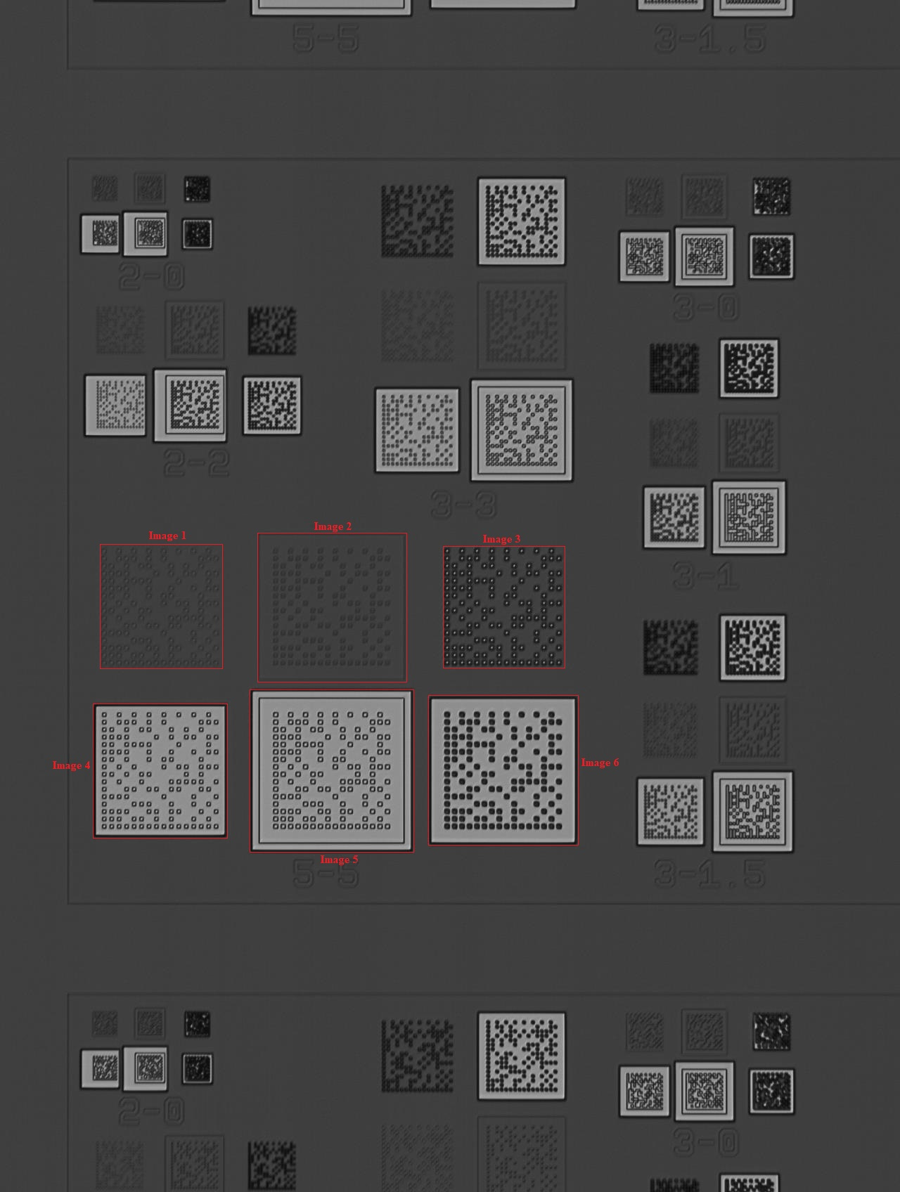

***Die # 3-1.5***

**Image 1:**

**Bottom-Left** # 865px, 1010px

**Top-Right** # 1043px, 831px

**Image 2:**

**Bottom-Left** # 972px, 1020px

**Top-Right** # 1169px, 822px

**Image 3:**

**Bottom-Left** # 864px, 1127px

**Top-Right** # 1041px, 943px

**Image 4:**

**Bottom-Left** # 971px, 1138px

**Top-Right** # 1169px, 940px

**Image 5:**

**Bottom-Left** # 854px, 1254px

**Top-Right** # 1053px, 1045px

**Image 6:**

**Bottom-Left** # 962px, 1264px

**Top-Right** # 1179px, 1044px

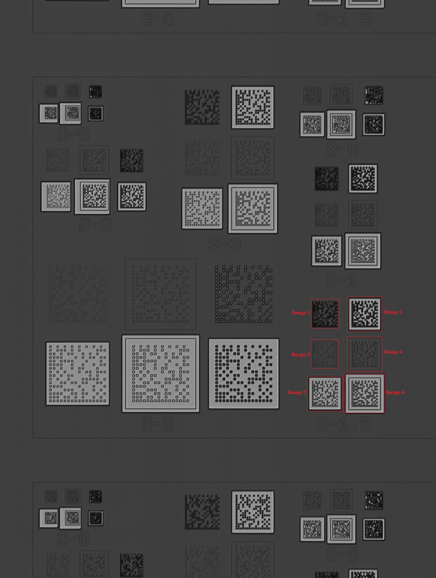

***Die # 3-1***

**Image 1:**

**Bottom-Left** # 874px, 610px

**Top-Right** # 1046px, 436px

**Image 2:**

**Bottom-Left** # 971px, 618px

**Top-Right** # 1158px, 430px

**Image 3:**

**Bottom-Left** # 872px, 715px

**Top-Right** # 1043px, 543px

**Image 4:**

**Bottom-Left** # 971px, 725px

**Top-Right** # 1159px, 535px

**Image 5:**

**Bottom-Left** # 864px, 832px

**Top-Right** # 1054px, 640px

**Image 6:**

**Bottom-Left** # 960px, 839px

**Top-Right** # 1169px, 631px

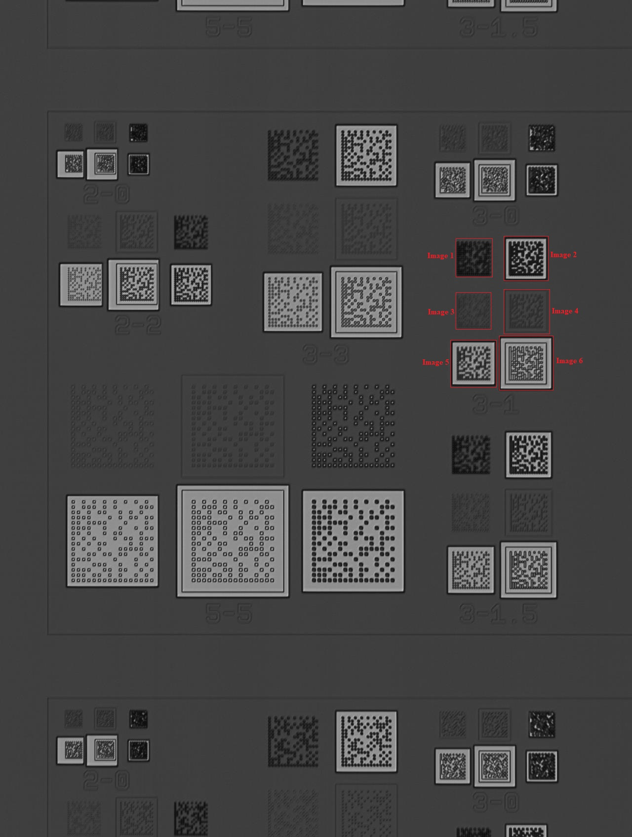

***Die # 2-2***

**Image 1:**

**Bottom-Left** # 86px, 553px

**Top-Right** # 256px, 385px

**Image 2:**

**Bottom-Left** # 182px, 562px

**Top-Right** # 369px, 377px

**Image 3:**

**Bottom-Left** # 302px, 555px

**Top-Right** # 473px, 384px

**Image 4:**

**Bottom-Left** # 69px, 671px

**Top-Right** # 258px, 482px

**Image 5:**

**Bottom-Left** # 168px, 678px

**Top-Right** # 372px, 474px

**Image 6:**

**Bottom-Left** # 295px, 669px

**Top-Right** # 479px, 484px

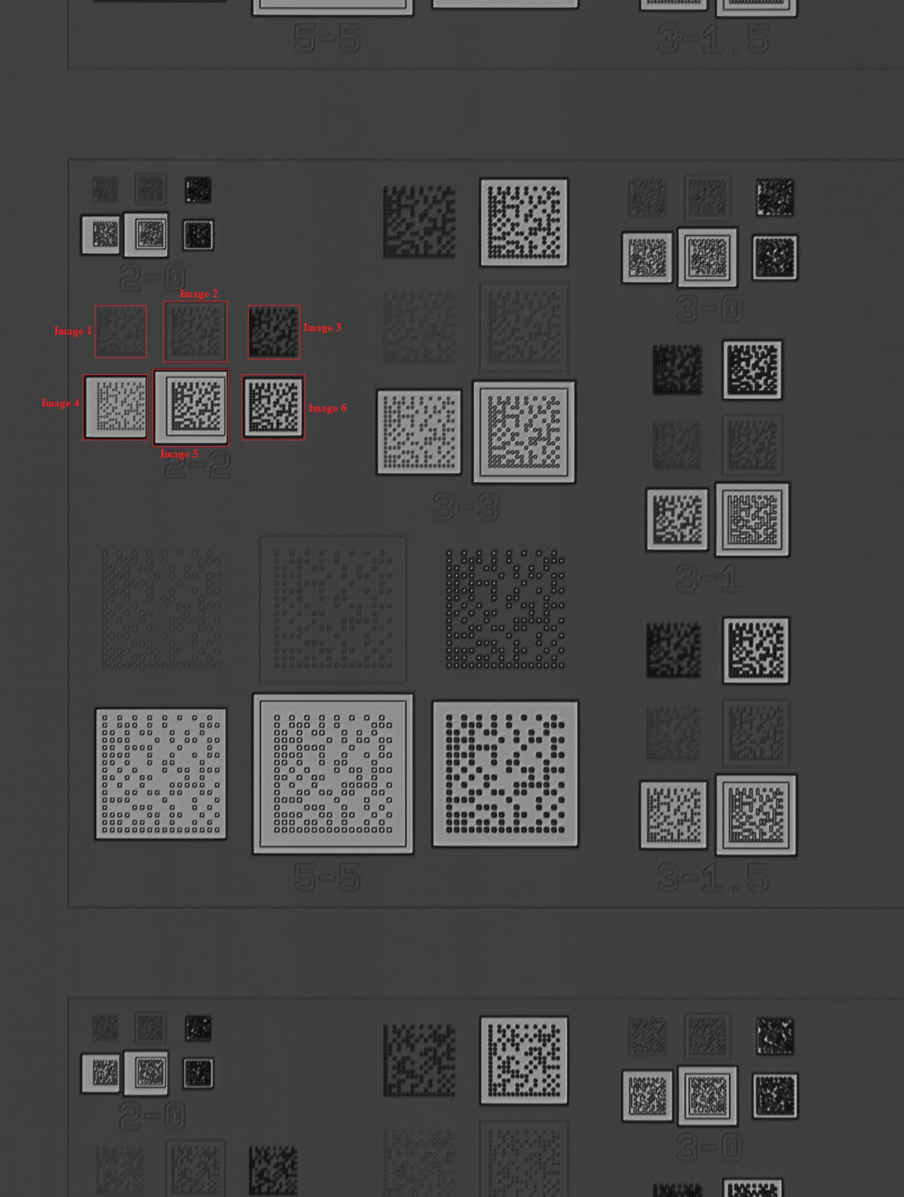

***Die # 3-3***

**Image 1:**

**Bottom-Left** # 491px, 416px

**Top-Right** # 696px, 213px

**Image 2:**

**Bottom-Left** # 630px, 428px

**Top-Right** # 855px, 201px

**Image 3:**

**Bottom-Left** # 492px, 565px

**Top-Right** # 695px, 361px

**Image 4:**

**Bottom-Left** # 627px, 578px

**Top-Right** # 856px, 349px

**Image 5:**

**Bottom-Left** # 482px, 723px

**Top-Right** # 704px, 501px

**Image 6:**

**Bottom-Left** # 616px, 737px

**Top-Right** # 866px, 487px

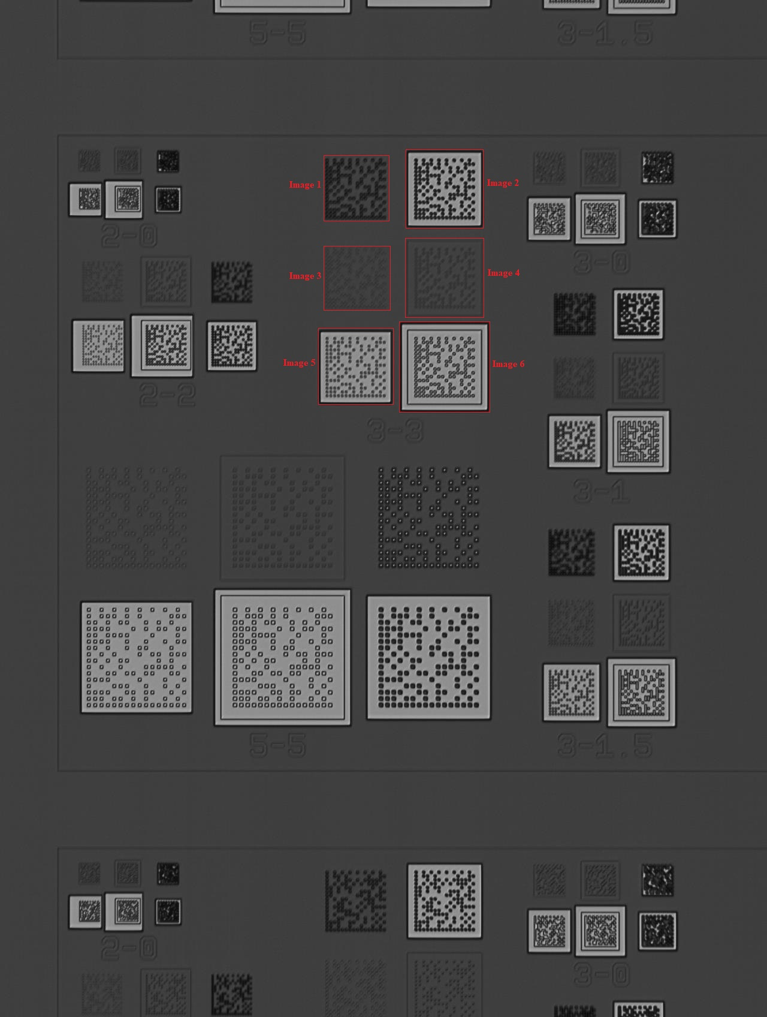

***Die # 3-0***

**Image 1:**

**Bottom-Left** # 839px, 1548px

**Top-Right** # 993px, 1390px

**Image 2:**

**Bottom-Left** # 918px, 1552px

**Top-Right** # 1085px, 1384px

**Image 3:**

**Bottom-Left** # 1019px, 1545px

**Top-Right** # 1175px, 1390px

**Image 4:**

**Bottom-Left** # 850px, 1639px

**Top-Right** # 1003px, 1465px

**Image 5:**

**Bottom-Left** # 908px, 1646px

**Top-Right** # 1094px, 1459px

**Image 6:**

**Bottom-Left** # 1014px, 1635px

**Top-Right** # 1180px, 1470px

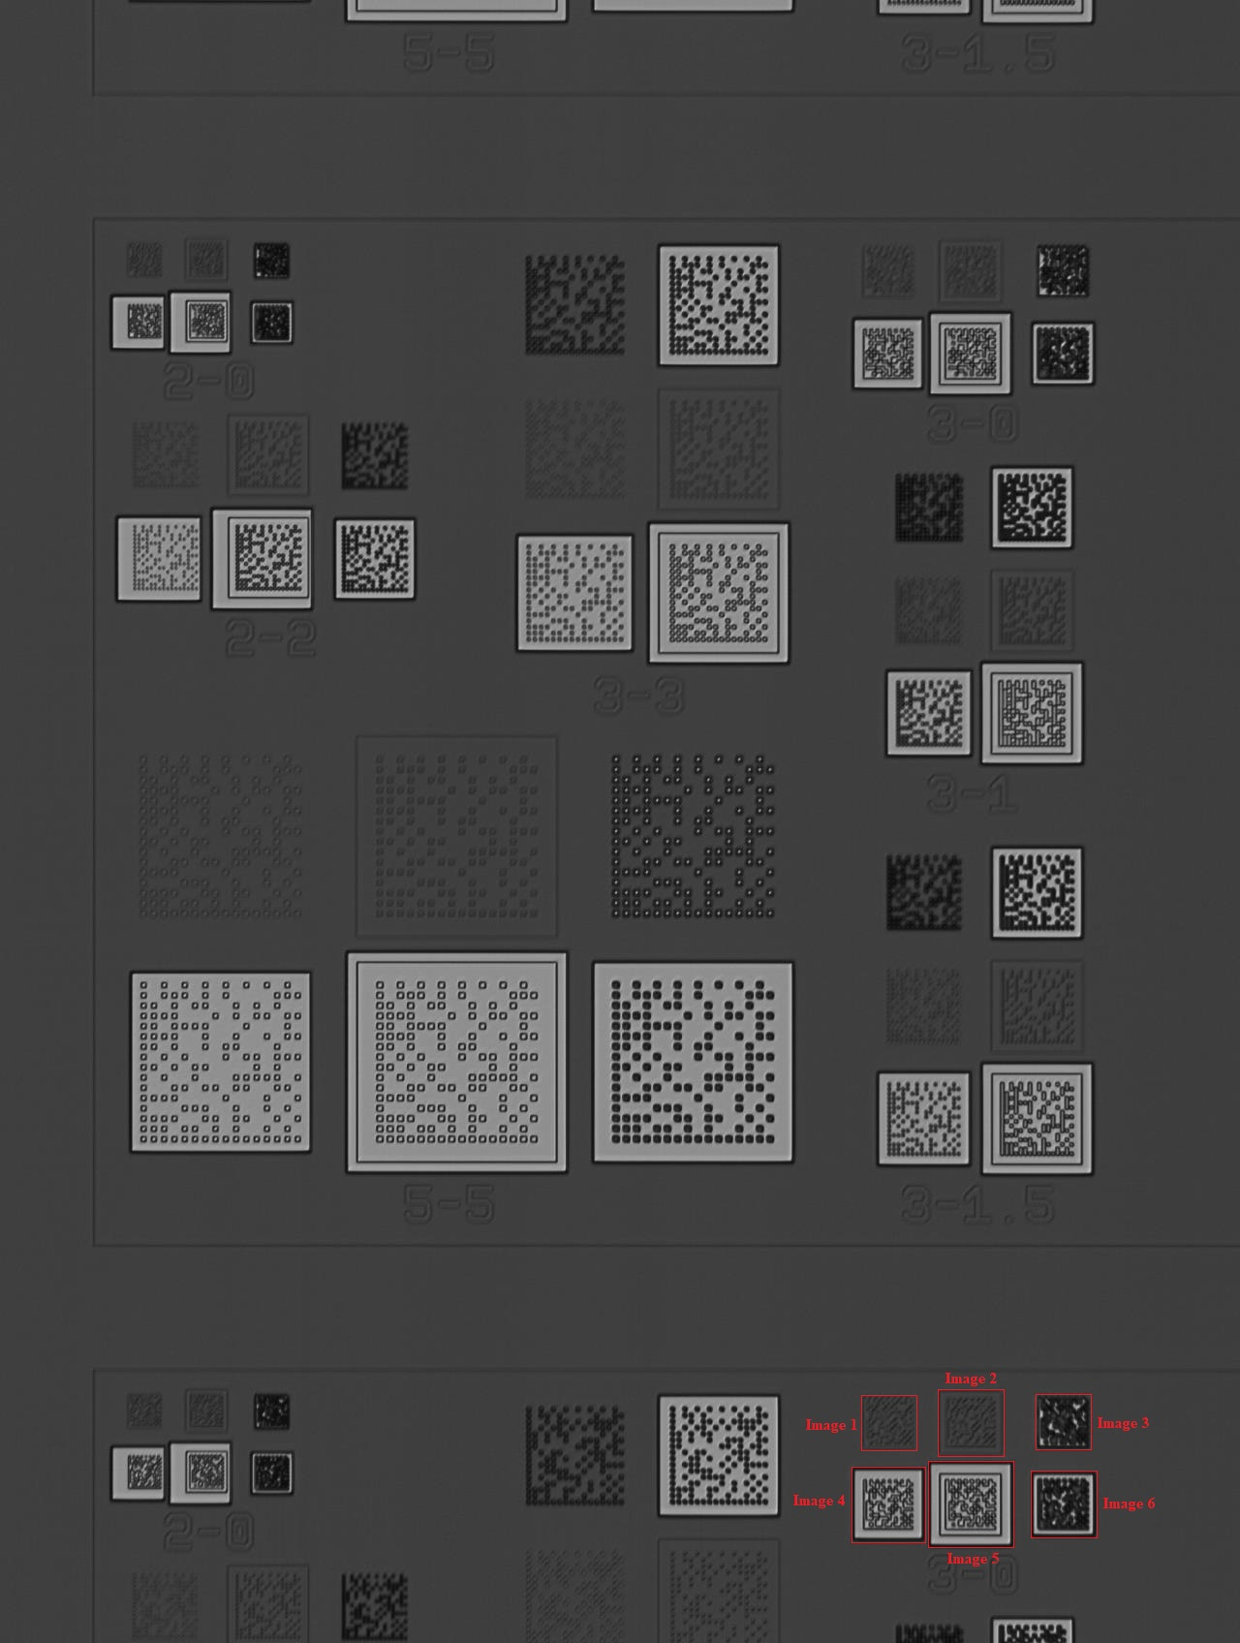

***Die # 2-0***

**Image 1:**

**Bottom-Left** # 114px, 301px

**Top-Right** # 186px, 228px

**Image 2:**

**Bottom-Left** # 175px, 305px

**Top-Right** # 257px, 226px

**Image 3:**

**Bottom-Left** # 240px, 304px

**Top-Right** # 324px, 229px

**Image 4:**

**Bottom-Left** # 94px, 378px

**Top-Right** # 189px, 288px

**Image 5:**

**Bottom-Left** # 159px, 385px

**Top-Right** # 256px, 289px

**Image 6:**

**Bottom-Left** # 241px, 369px

**Top-Right** # 323px, 292px

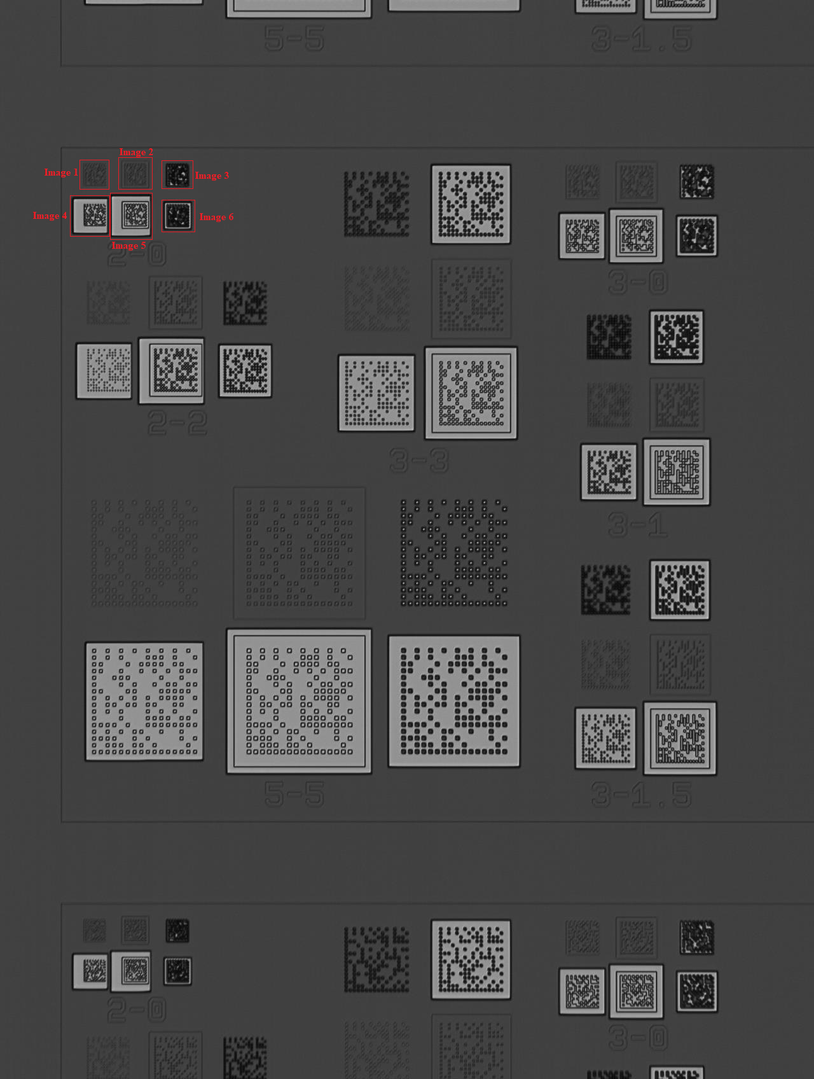

***Additional DMs in P3***

**Image 1:**

**Bottom-Left** # 113px, 1489px

**Top-Right** # 188px, 1414px

**Image 2:**

**Bottom-Left** # 178px, 1489px

**Top-Right** # 251px, 1418px

**Image 3:**

**Bottom-Left** # 244px, 1489px

**Top-Right** # 316px, 1414px

**Image 4:**

**Bottom-Left** # 102px, 1559px

**Top-Right** # 184px, 1476px

**Image 5:**

**Bottom-Left** # 160px, 1570px

**Top-Right** # 255px, 1469px

**Image 6:**

**Bottom-Left** # 241px, 1555px

**Top-Right** # 319px, 1476px

**Image 7:**

**Bottom-Left** # 518px, 1573px

**Top-Right** # 671px, 1417px

**Image 8:**

**Bottom-Left** # 658px, 1587px

**Top-Right** # 830px, 1415px

**Image 9:**

**Bottom-Left** # 874px, 1516px

**Top-Right** # 966px, 1416px

**Image 10:**

**Bottom-Left** # 953px, 1515px

**Top-Right** # 1060px, 1414px

**Image 11:**

**Bottom-Left** # 1047px, 1575px

**Top-Right** # 1152px, 1419px

**Image 12:**

**Bottom-Left** # 864px, 1609px

**Top-Right** # 970px, 1496px

**Image 13:**

**Bottom-Left** # 940px, 1620px

**Top-Right** # 1064px, 1489px

**Image 14:**

**Bottom-Left** # 1047px, 1607px

**Top-Right** # 1149px, 1493px

**Image 15:**

**Bottom-Left** # 113px, 1694px

**Top-Right** # 228px, 1598px

**Image 16:**

**Bottom-Left** # 211px, 1694px

**Top-Right** # 344px, 1590px

**Image 17:**

**Bottom-Left** # 325px, 1694px

**Top-Right** # 446px, 1606px

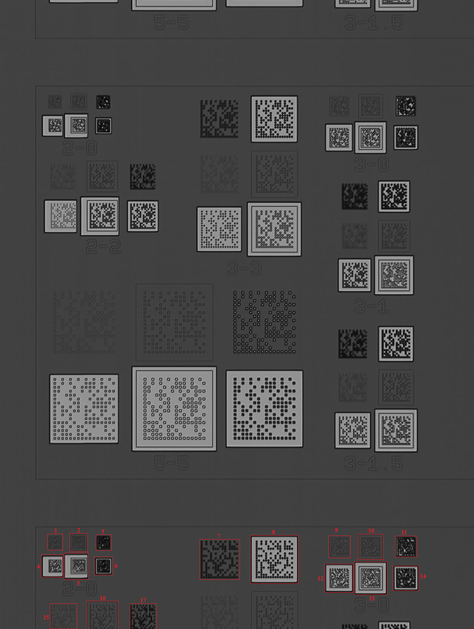

**P4 Category**

**Total Dies** # 10-10

**Pixel Rearrangement** # 50px

***Die # 10-10***

**Image 1:**

**Bottom-Left** # 200px, 813px

**Top-Right** # 632px, 381px

**Image 2:**

**Bottom-Left** # 605px, 852px

**Top-Right** # 1121px, 338px

**Image 3:**

**Bottom-Left** # 192px, 1267px

**Top-Right** # 642px, 815px

**Image 4:**

**Bottom-Left** # 594px, 1306px

**Top-Right** # 1130px, 773px

